Batch: B4 Roll No.:16010122286
Experiment No. 06
Grade: AA / AB / BB / BC / CC / CD /DD

Title: Google CLoudSkill Boost Lab

Objective:
Explore Google CLoudSkill Boost Lab

Expected Outcome of Experiment:

CO | Outcome
CO4 | Build cloud services and applications.

Books/ Journals/ Websites referred:

- https://www.cloudskillsboost.google/focuses/3563?parent=catalog
- https://www.cloudskillsboost.google/focuses/2794?parent=catalog

Abstract
Google Cloud Skill Boost Lab is an interactive learning platform that provides hands-on experience with Google Cloud technologies. It offers real-world labs covering cloud computing, networking, security, AI, and application deployment, allowing users to practice skills in a live cloud environment without needing personal infrastructure.

Related Theory
Cloud computing enables on-demand access to computing resources, such as servers, storage, and networking, over the internet. Google Cloud provides a suite of cloud services that help organizations deploy, manage, and scale applications efficiently while maintaining security and compliance.

Web Hosting and Deployment
Google Cloud supports various hosting solutions, including Compute Engine, App Engine, and Kubernetes Engine, allowing developers to deploy websites and applications seamlessly. These services provide flexibility in choosing between virtual machines, containers, and fully managed hosting.

Managed Hosting and Serverless Platforms
Google Cloud offers Firebase Hosting, Cloud Run, and Cloud Functions, which provide serverless environments that scale automatically. These managed services reduce operational overhead by handling infrastructure, security, and scaling, enabling developers to focus on code rather than server management.

Programming Environments and Frameworks
Google Cloud supports multiple programming languages and frameworks, including Python, Java, Node.js, and Go. Developers can use Cloud Shell and Cloud Code to write, test, and deploy applications directly in the cloud environment.

Application Configuration and Deployment
Cloud applications require proper configuration for performance and security. Google Kubernetes Engine (GKE) and Cloud Build allow automated deployment, while Infrastructure as Code (IaC) tools like Terraform ensure consistent application configurations across environments.

Scalability and Performance Optimization
Google Cloud provides auto-scaling, load balancing, and caching solutions to optimize application performance. Services like Cloud Spanner, Cloud CDN, and Memorystore help improve response times and ensure efficient resource utilization, making applications highly available and scalable.
This summary provides an overview of Google Cloud Skill Boost Lab and its core components related to cloud application development and deployment.

Implementation Details:

Lab 1:-

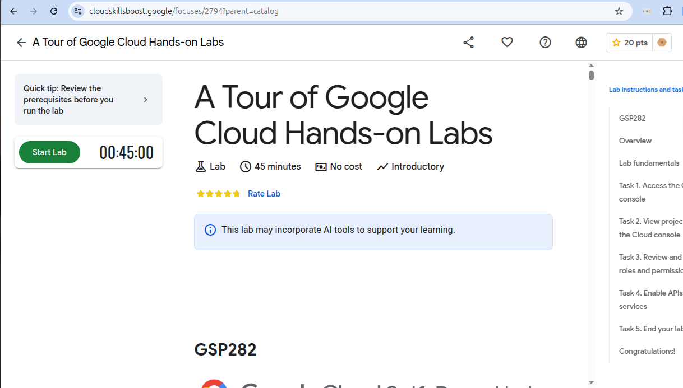

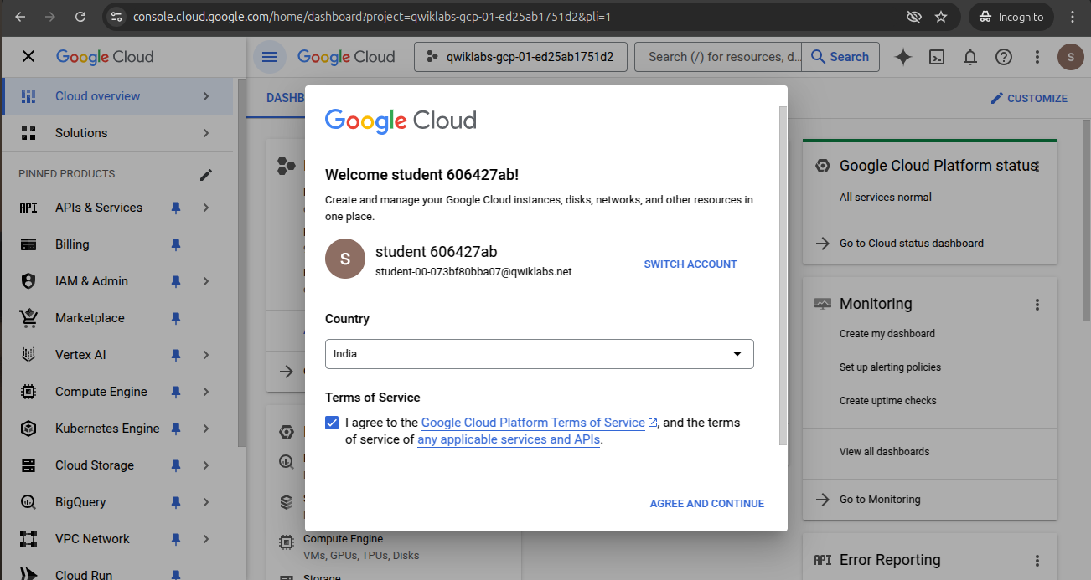

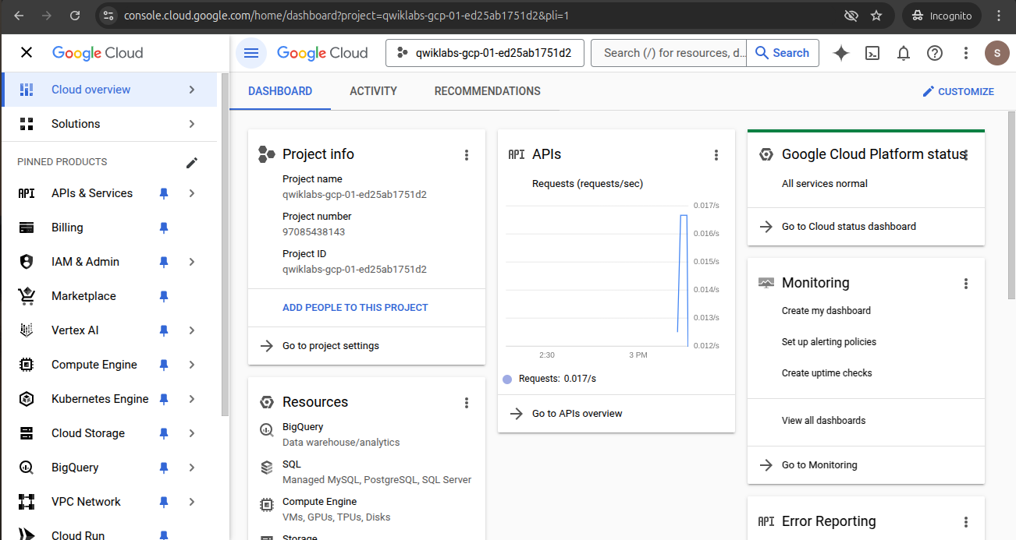

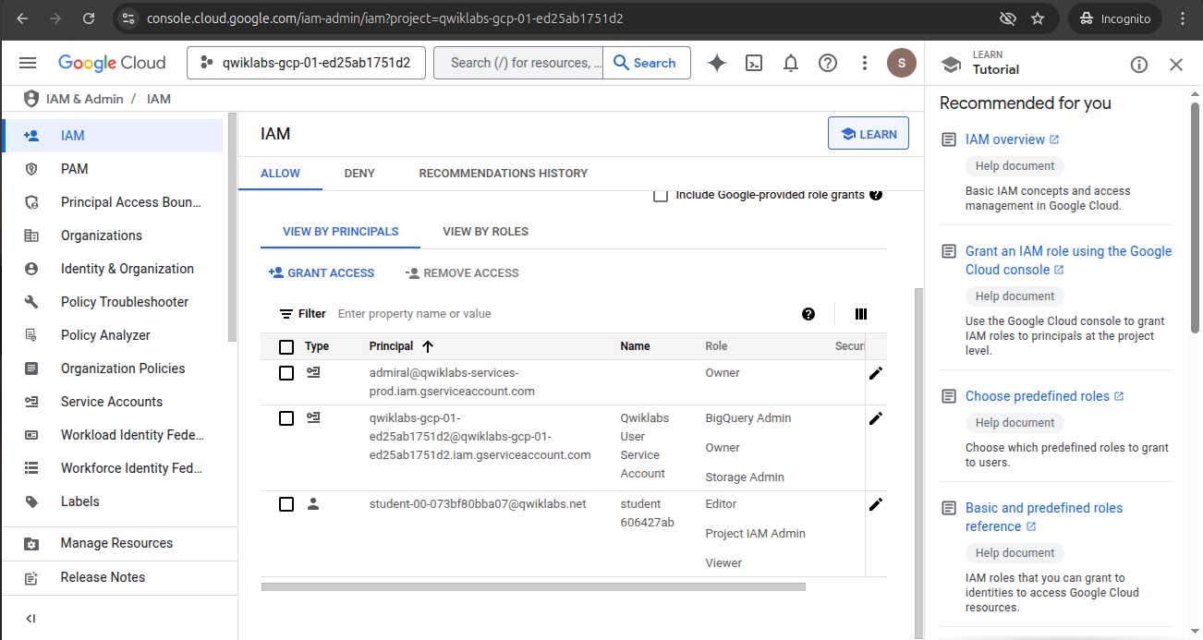

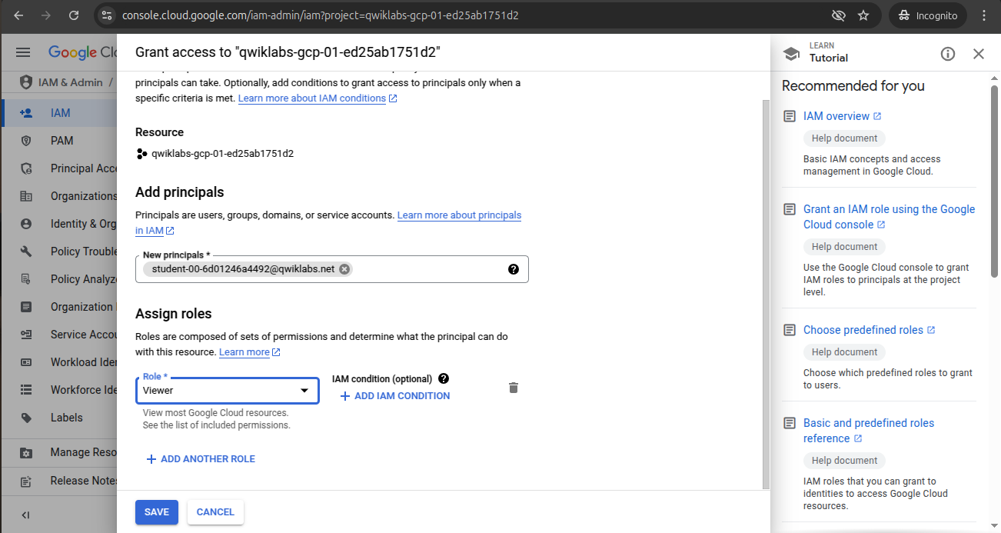

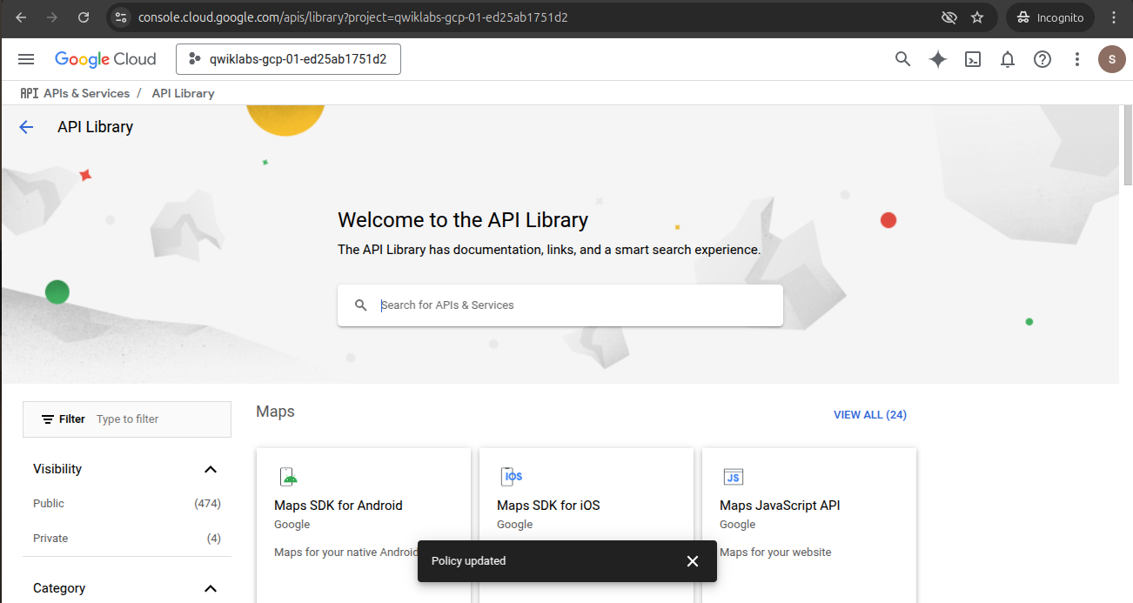

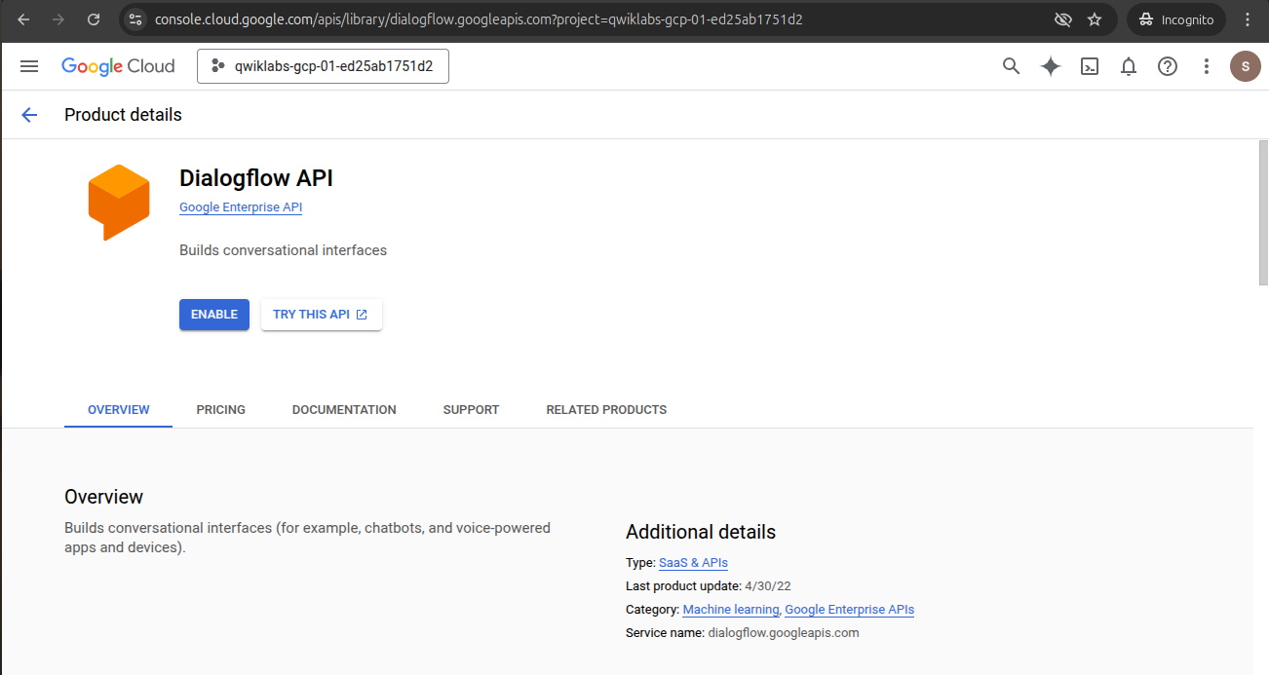

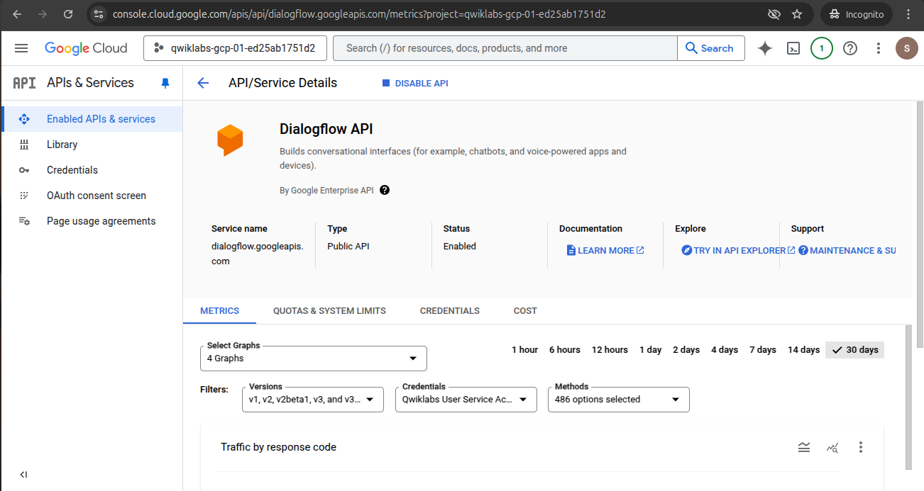

Lab 2:-

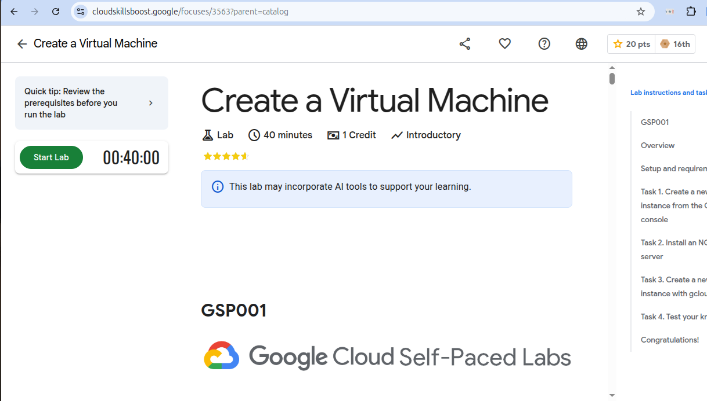

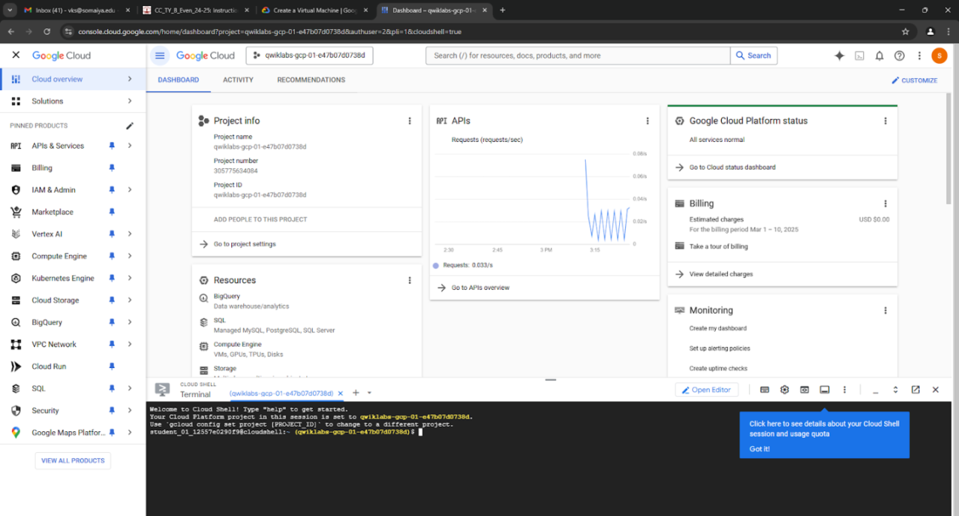

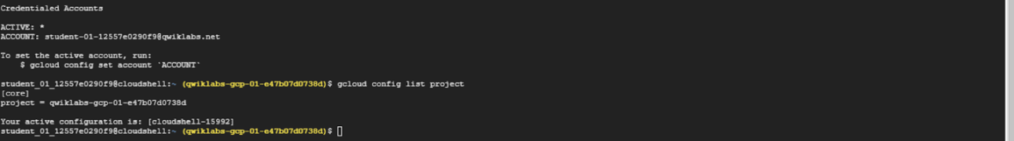

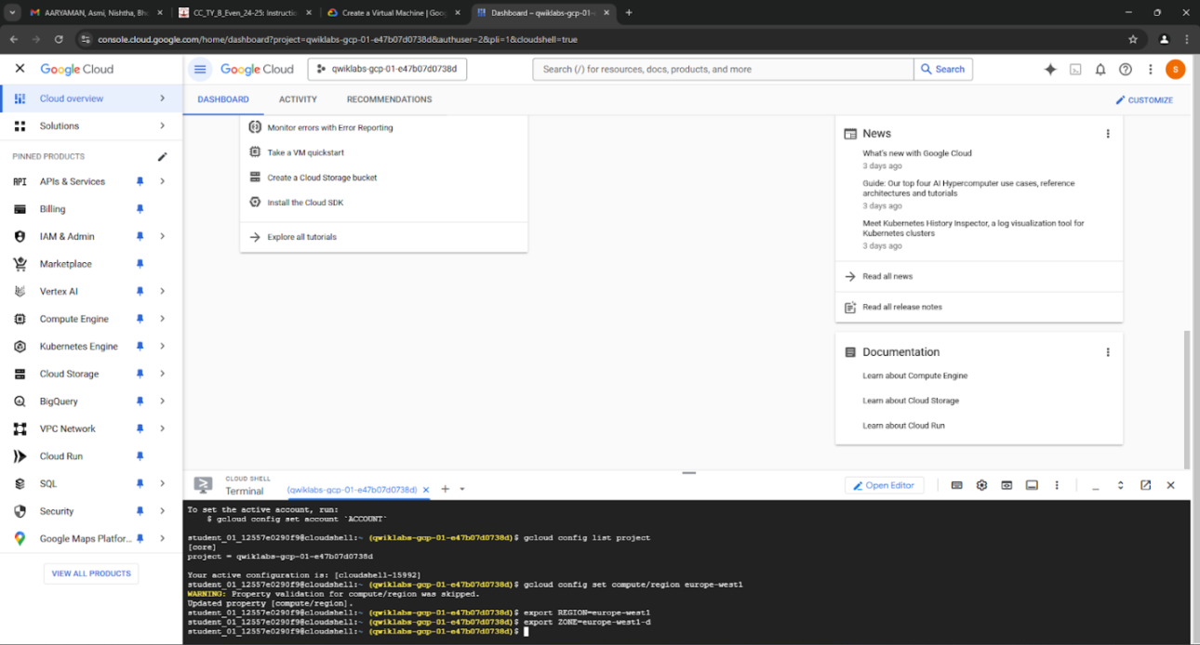

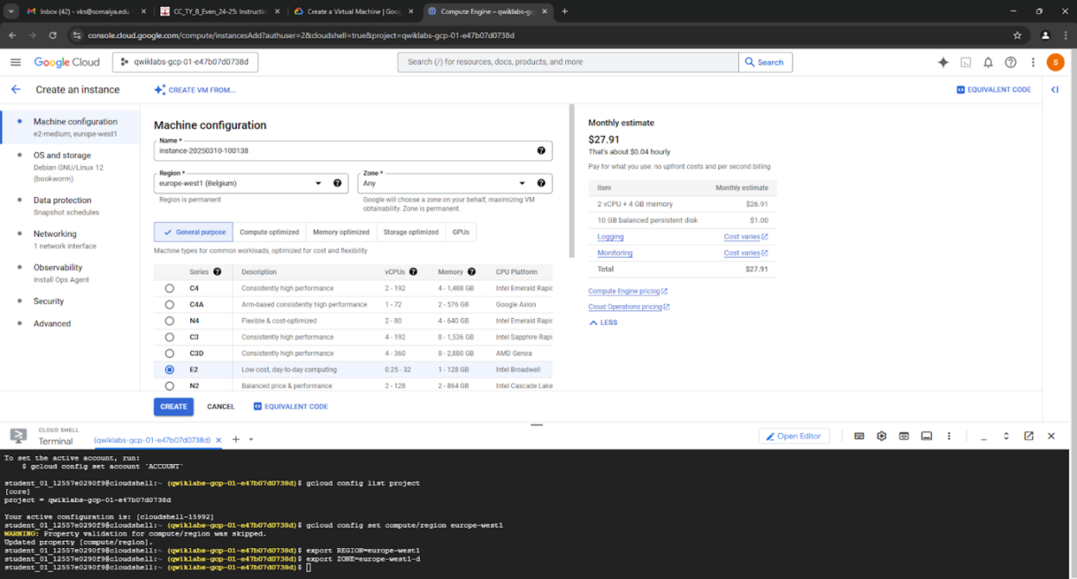

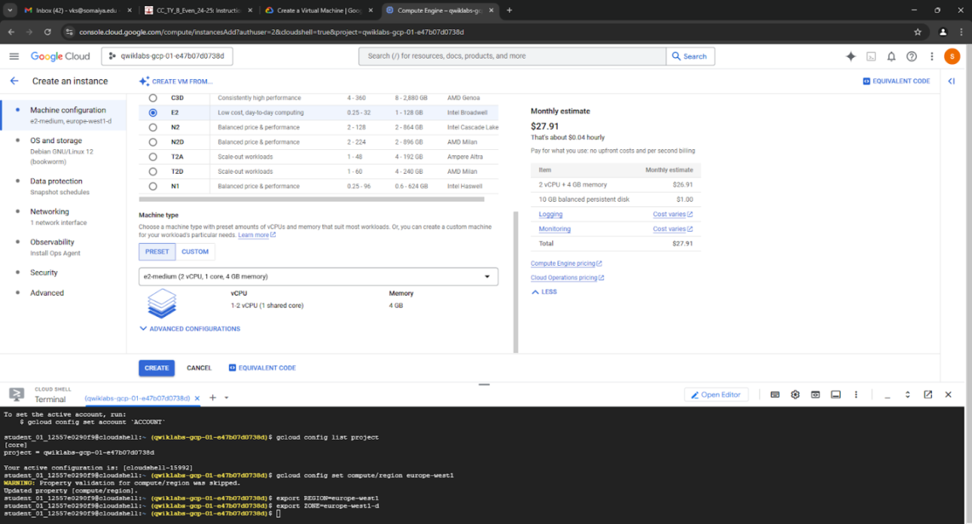

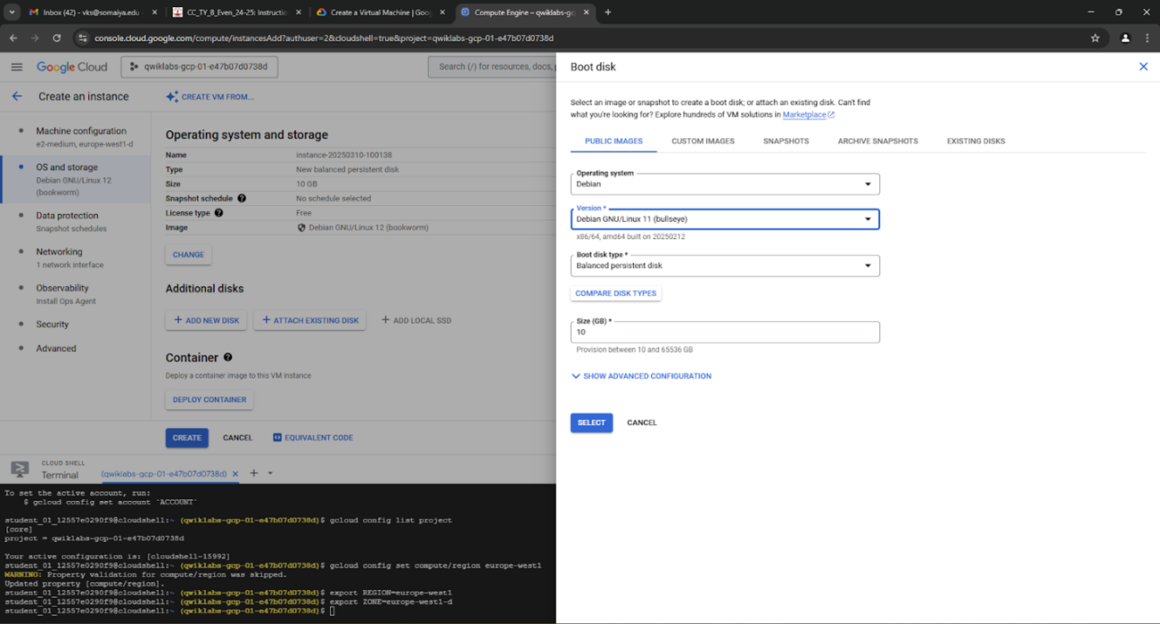

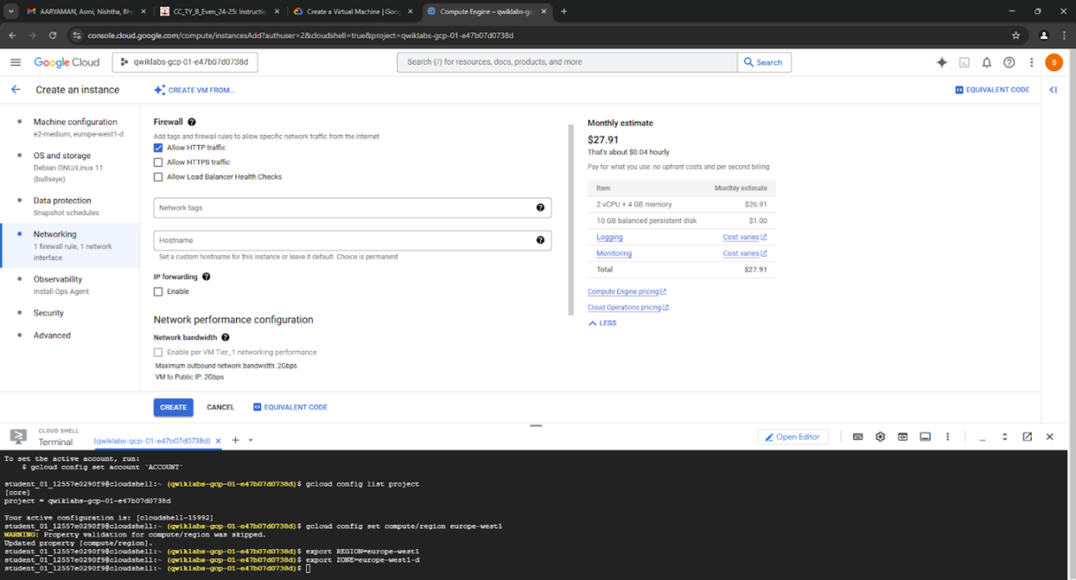

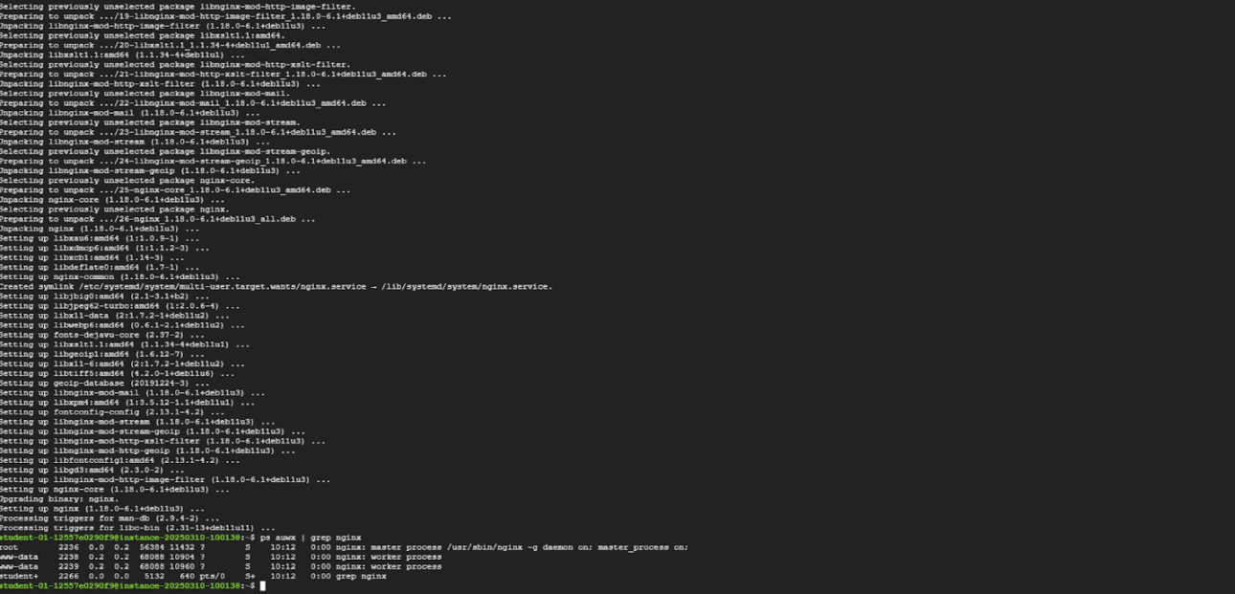

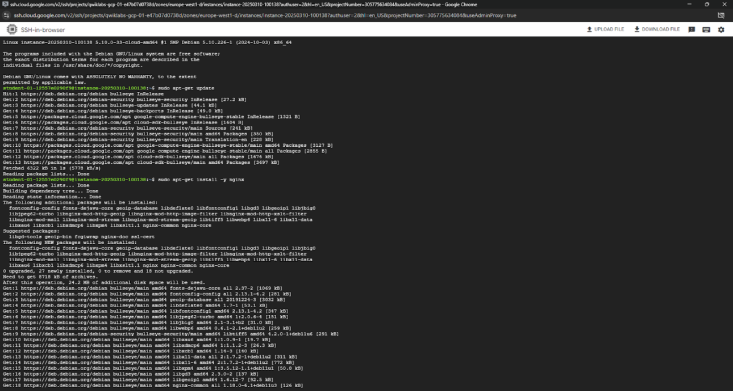

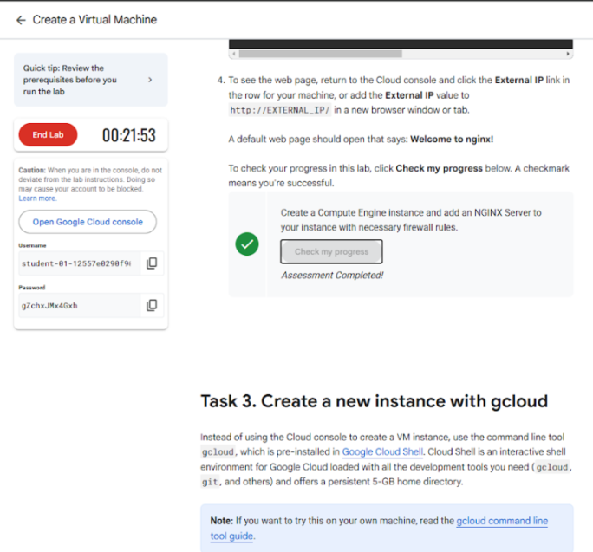

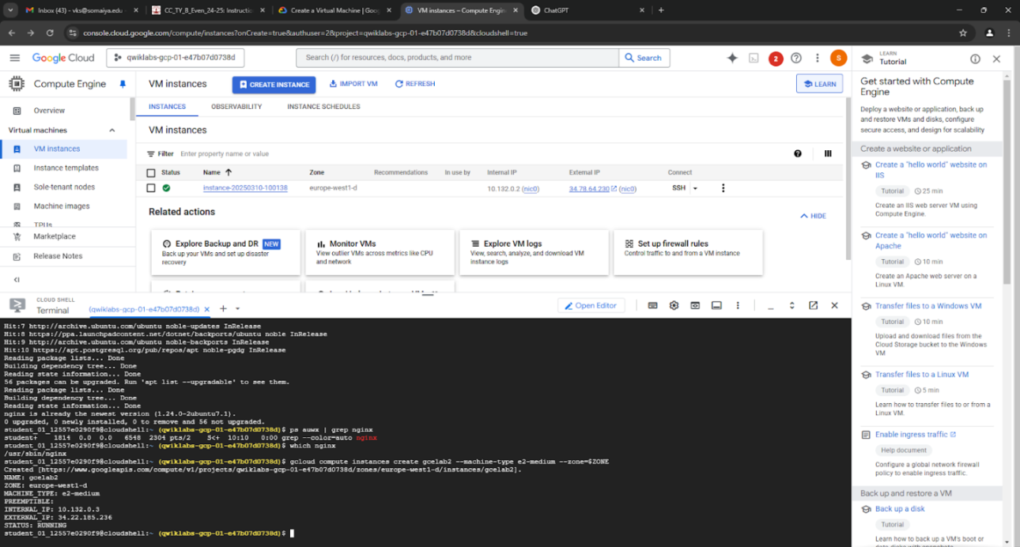

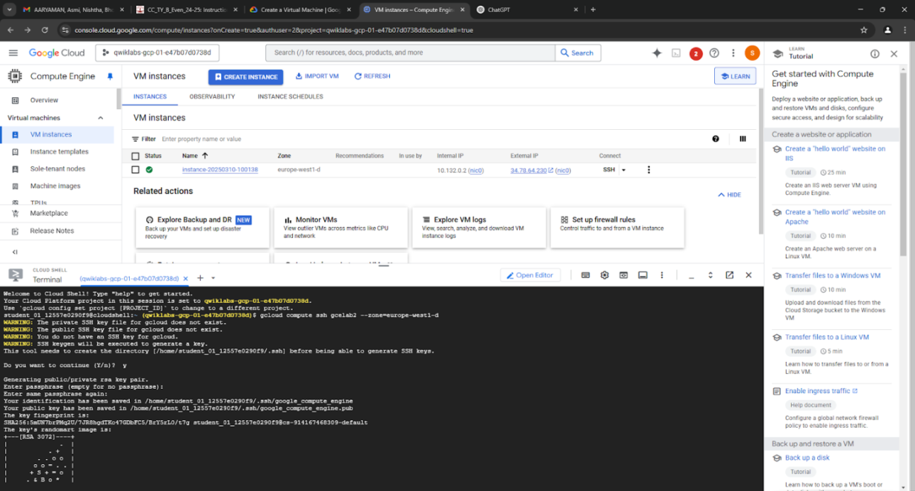

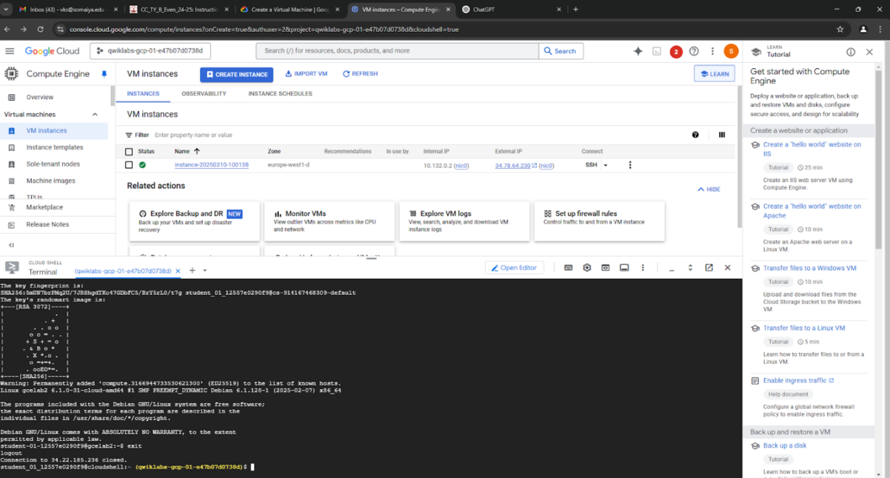

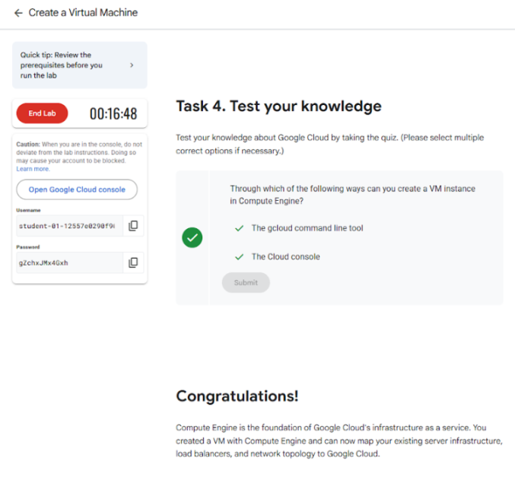

Conclusion:-
Successfully explored Google CLoudSkill Boost Lab

